

**Excel Assignment - 16**

1. What is a Macro? How is it useful in Excel or in your daily work?

Answer: A macro is a small program that you make in Excel that automates tasks.

Basically, this "thing", the macro, can save you hours of time. You can create macros that do almost anything in Excel and even other Microsoft Office programs

Macros are useful when you want to automate a repetitive, tedious, or complex process.

For example, you can create a macro that searches through all of the data in an Excel Workbook, compiles the important information, and emails that information through Outlook, and you can do all of this with just the click of a button once you make the macro.

2. What is VBA? Write its full form and briefly explain why VBA is used in Excel?

Answer

Macros are made using VBA, which stands for Visual Basic for Applications.

Visual Basic is programming language, and VBA is a programming language used to create Macros.

VBA is used to write programs for the Windows operating system and runs as an internal programming language in Microsoft Office (MS Office, Office) applications such as Access,Excel, PowerPoint, Publisher, Word, and Visio. VBA allows users to customize beyond what is normally available with MS Office host applications.

* Visual Basic for Applications is a computer programming language developed and owned by Microsoft.
* With VBA you can create macros to automate repetitive word- and data-processing functions, and generate custom forms, graphs, and reports.
* VBA functions within MS Office applications; it is not a stand-alone product.
* VBA is accessed in Excel by hitting Alt + F11 while having an Excel workbook present.
* VBA leverages objects, variables, properties, projects, logical operators, and modules to make statements recognizable by debugging processes.

3. How do you record a macro? Write detailed steps to create a macro to automatically make the following table in bold and to create borders for it in excel.

Answer:

The **Developer** tab isn't displayed by default, but we can add it to the ribbon.

1. On the **File** tab, go to **Options** > **Customize Ribbon**.
2. Under **Customize the Ribbon** and under **Main Tabs**, select the **Developer** check box.

After we show the tab, the **Developer** tab stays visible, unless we clear the check box or have to reinstall a Microsoft 365 program.

The **Developer** tab is the place to go when you want to do or use the following:

* Write macros.
* Run macros that you previously recorded.
* Use XML commands.
* Use ActiveX controls.
* Create applications to use with Microsoft 365 programs.
* Use form controls in Microsoft Excel.
* Work with the ShapeSheet in Microsoft Visio.
* Create new shapes and stencils in Microsoft Visio.

hi 78

hello 69

ineuron 45

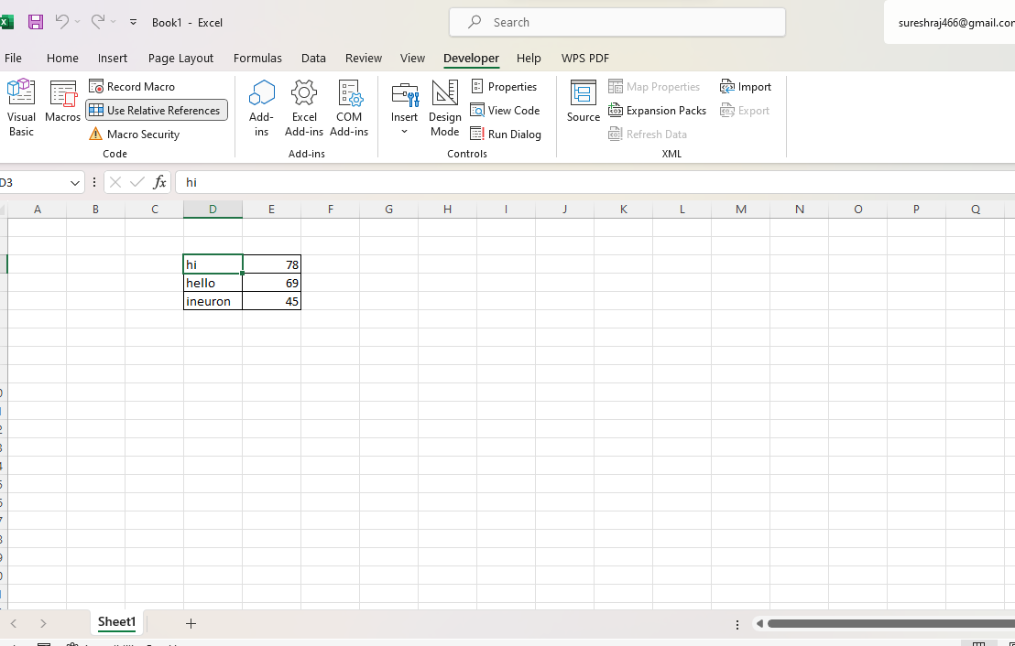

4. What do you mean when we say VBA Editor?

Answer: Microsoft Visual Basic for Applications (VBA) enables non-programmers to record, create, and edit macros that can automate tasks in Office applications.

5. Briefly describe the interface of a VBA editor? What is properties window? And what is watch window? How do you display these windows?

Answer:

You can **open the VBE using either of the following methods**:

* Click on “Visual Basic” in the Developer tab of the Ribbion.  
    
  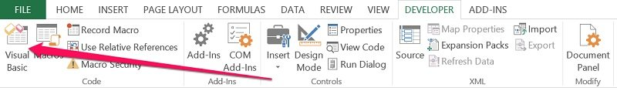
* Use the keyboard shortcut “Alt + F11”.

## How Does The Visual Basic Editor Look

The basic VBE window can be divided in the following 6 sections, all of which I explain below. In reality, **there are more components** than those which appear in this screenshot (such as the Locals and Watch Windows) but, since they're more advanced, I'll cover them in a future Excel tutorial.

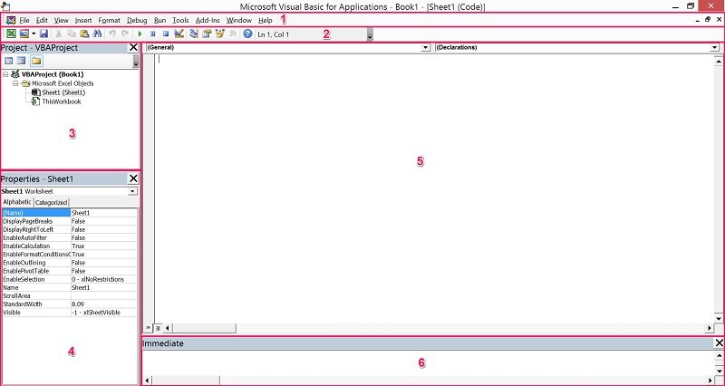

The Visual Basic Editor:

* Has several windows.
* Is highly customizable.

As a consequence of the above, there is the possibility that your VBE window doesn't look exactly as the screenshot above.

In fact, if this is the first time that you're opening the Visual Basic Editor, you probably can't see element #6 that appears in the lower part of the image above. The reason is that this particular window (known as the Immediate Window) is, by default, hidden. I explain how you can easily unhide it below.

As you get more familiar with the VBE, you'll notice that you have a lot of flexibility regarding how the interface looks like. The Visual Basic Editor allows you to, for example:

* Hide or un-hide windows.
* Move or re-arrange windows.
* Dock windows.

6. What is an immediate Window and what is it used for?

Answer:

The Immediate window displays information resulting from debugging statements in your code or from commands typed directly into the window.

To display the Immediate window

* From the View menu, choose Immediate window (CTRL+G).

To execute code in the Immediate window

1. Type a line of code in the Immediate window.
2. Press ENTER to execute the statement.

Use the Immediate window to:

* Test problematic or newly written code.
* Query or change the value of a variable while running an application. While execution is halted, assign the variable a new value as you would in code.
* Query or change a property value while running an application.
* Call procedures as you would in code.
* View debugging output while the program is running.

